**Class:** Third Year (Computer Science and Engineering)

**Year:** 2020-21 **Semester:** 2

**Course:** Advanced Web and Mobile Application Development Lab (4CS381)

**Exam Seat No:**

Name: Mahendra Bhimrao Gharge

Exam Seat Number : 2018BTECS00033

**Problem Statement 1**

**Statement 1 :**

Create an Express App for Conference registration form with following requirements:  
1. Student should fill details (Name, City, Branch, Conference)  
2. Use 'GATEForm.html' route and also use root route.  
3. Use GET method method to transfer and display the data using JSON  
4. Run the Application

**Screenshot 1:**

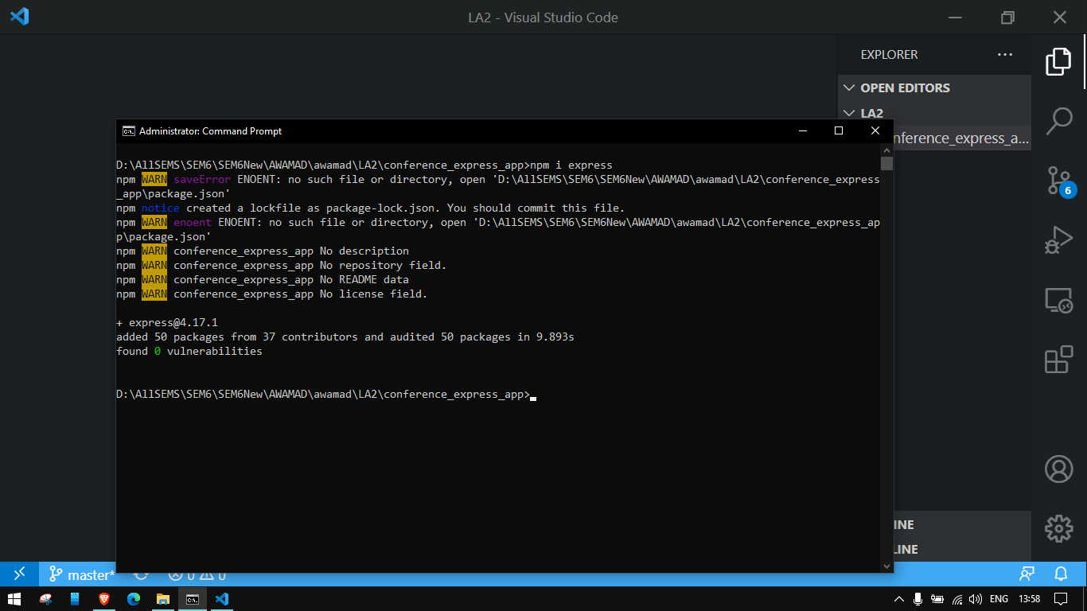

**Information 1: Installed express usng npm I express.**

**Screenshot 2:**

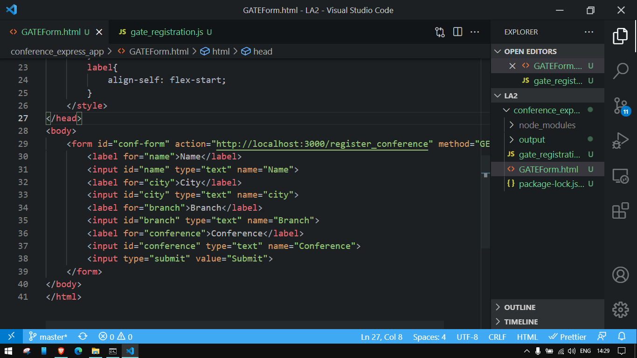

**Information 2: Form code**

**Screenshot 3:**

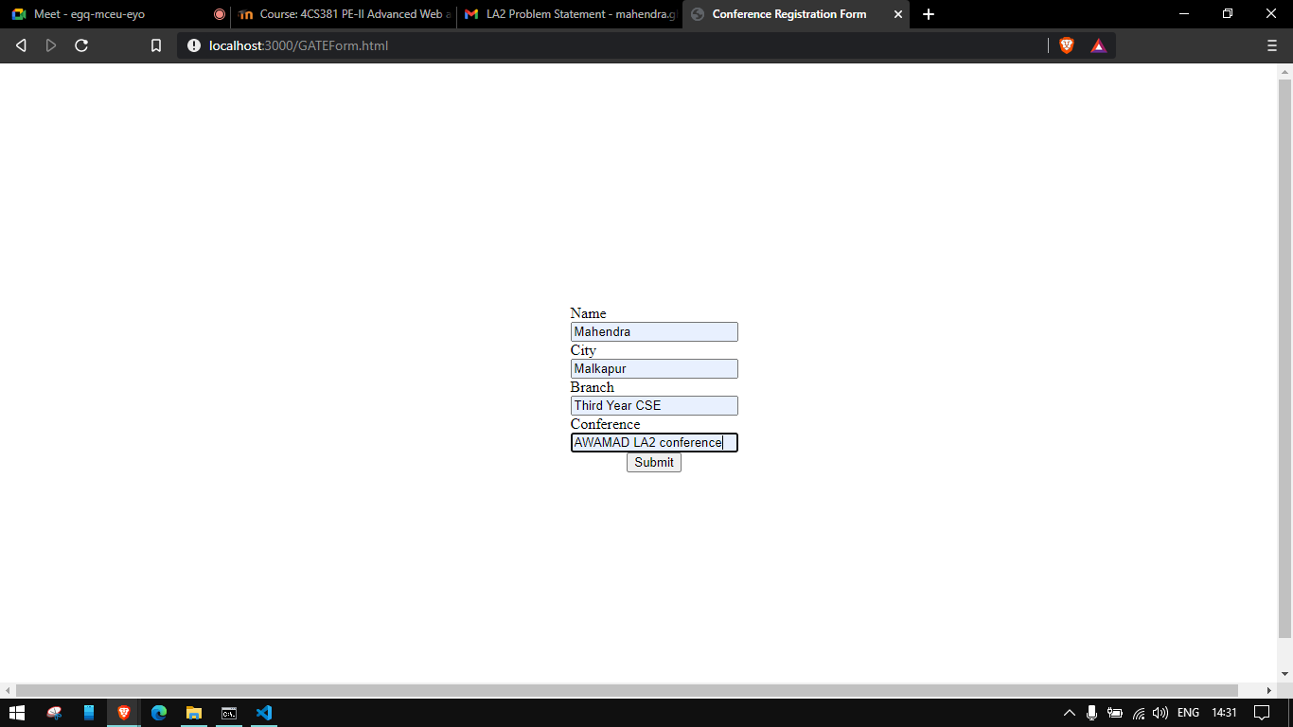

**Information 3: Form**

**Screenshot 4:**

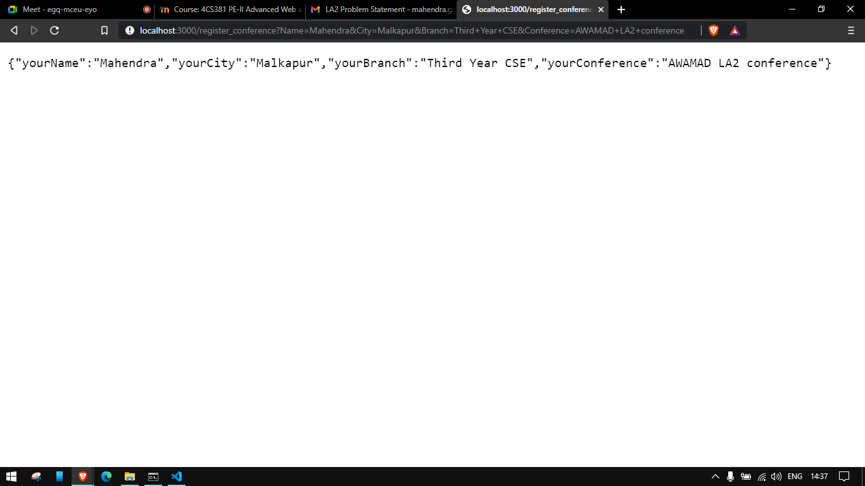

**Information 4: JSON data**

**Problem Statement 2**

**Statement:**

Create a React App for Conference Registration form with following requirements:

1. Use Components and props appropriately  
2. Use Controlled Components  
3. Create at least one user defined component  
4. Run the application

**Screenshot 1:**

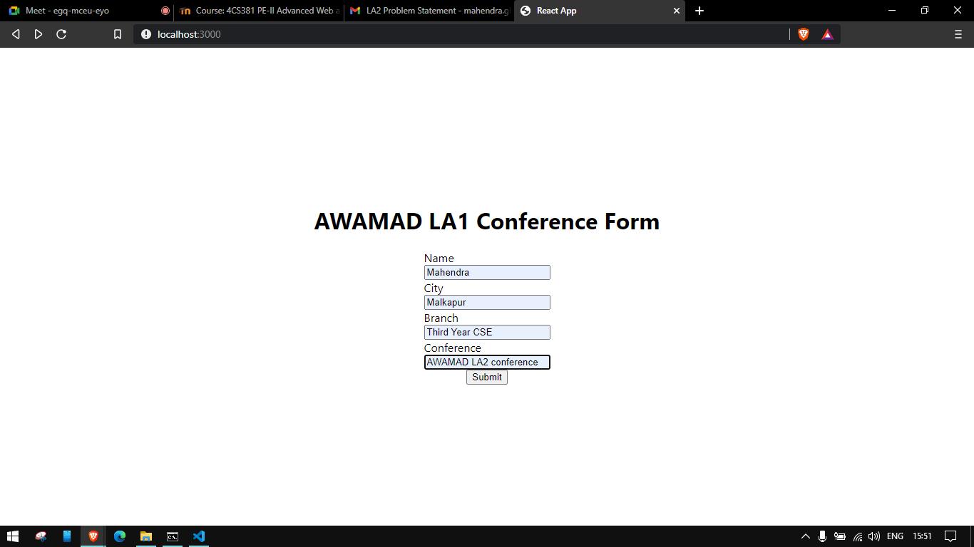

**Information 1:Controlled form React**

**Screenshot 2:**

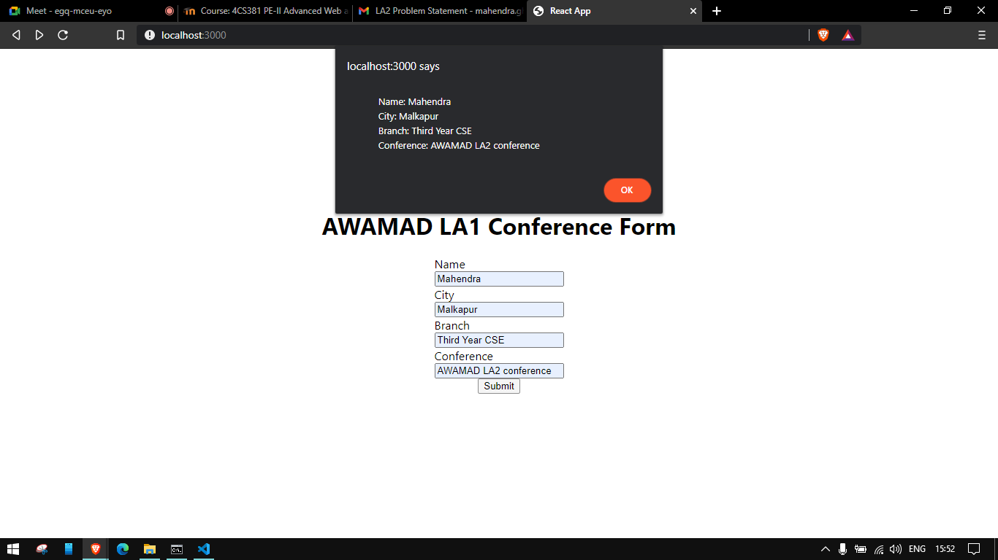

**Information 2: Alert on submit**

**Screenshot 3:**

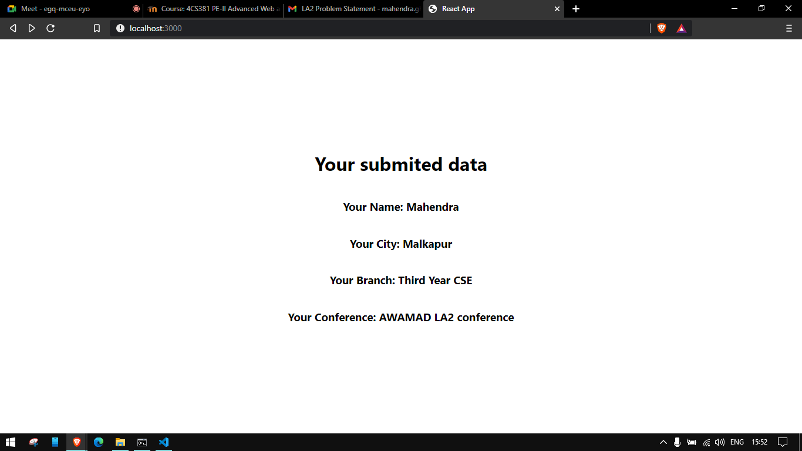

**Information 3: Output on submit**

**GitHub Link: https://github.com/g-mahendra/awamad**